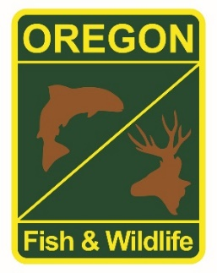

**State Fisheries Genetics Lab Tissue Sample Intake Form**

Please complete the top part of this form and send to: [kathleen.omalley@oregonstate.edu](mailto:kathleen.omalley@oregonstate.edu)

Make arrangements with us prior to dropping off the tissue samples and include a copy of this form with your samples.

**Project dropping off samples:**

Laura Street

**Person dropping off samples:**

**Phone: Email:**

541-826-8774 x 224 Laura.E.Street@state.or.us

**Description of samples (e.g. species, collection locations, collection dates, collection methods, number of samples, life stage; may attach spreadsheet):**

Winter Steelhead collected at Colle Rivers Hatchery (Rogue River) and the Applegate River from adult brood stock for 2019. Scales were collected from fish for age data, then the best scales were mounted and sent to the scale lab. Therefore these scales can be used for DNA analysis. There are 50 samples, 25 from each river and the spreadsheet with sizes, sex and collection dates are attached.

**If applicable, known origin (e.g. natural or hatchery):**

Mixed, it is on spreadsheet where 1 means wild and AD means hatchery

**Sample type (e.g. fin tissue, scale, muscle, etc):**

Scales

**Storage method (e.g. dry, 95% ethanol, RNA later, etc):**

Dry